Community harm and exploitation
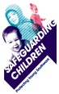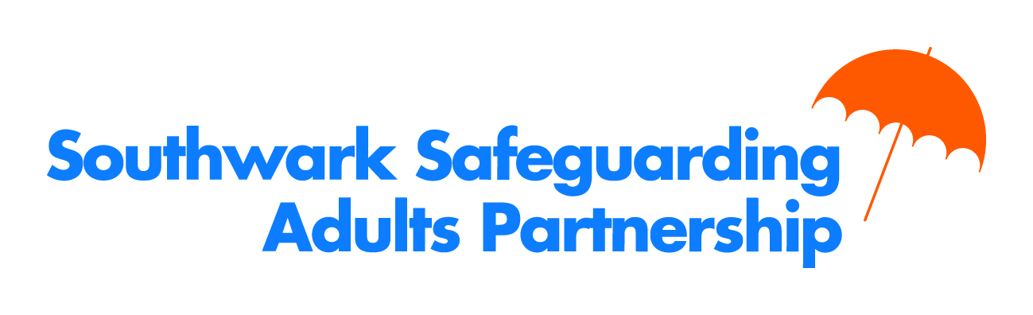
Knife crime, violence and exploitation have a negative effect on all those who live, work and visit Southwark. The council and partners are committed to support all sections of the community to address this problem. This information sheet aims to give brief guidance so that people can get the help they need to make Southwark a safer and better place for` all. We need to be clear about the facts:-
- Carrying a knife is illegal, this includes anything intended to be used to harm another person, like a sharpened comb
- Possession of a knife carries a prison sentence of up to 4 years even if it's not used
- Carrying a knife increases the risk of being injured and of other people being injured
- Police are allowed to stop and search someone if they believe a weapon is being carried
Young and vulnerable people are subject to developing forms of criminal and financial exploitation. “County Lines” is when drug gangs expand their operations to other areas, often using violence to drive out local dealers and exploiting children and vulnerable people to sell drugs.
“Square” or “Deets and Squares” is a form of money laundering where the proceeds of criminal activity is channelled through an often vulnerable person’s bank account, often the payment that they receive is subsequently described as a loan and used as a lever to make them transport drugs.

Parents and carers can speak to the Youth Offending Service (YOS) 020 7525 0900, if they are concerned that your child is “at risk of offending”. A member of the YOS team will be able to discuss the level of support that can be offered on a voluntary basis or referral to other support services.

If there is a crime being committed or someone is in immediate danger people should call 999 or if they have some information about a crime we would ask that they call the Police on 101. Further information is available here.
If people feel unable to report crimes to the police directly they can make an anonymous report to Crime Stoppers 0800 555 111.
Parents and carers can make a difference by talking through the issues with their children, see https://www.knifefree.co.uk/worried-young-person/ for guidance about how to approach this issue.

If as a parent you need further confidential support to deal with these issues you can call Family Lives 0808 800 2222 (formerly Parent Line).

If you have concerns for the welfare or safety of a child at risk from knife crime, violence and exploitation you can make a referral to the Multi-Agency Safeguarding Hub (MASH) 020 7525 1921 mash@southwark.gov.uk comprising the council and partners who will assess the risk and workout the best way to keep the child safe. Other services are listed overleaf.

Information about knife crime and knife carrying
Metropolitan Police Service  https://www.met.police.uk/StopKnifeCrime  Emergencies Phone 999 | The MPS website gives information about the risks relating to carrying a knife and reports on the activity that it is undertaking to tackle knife crime.
fearless.org  fearless.org | The fearless.org website is aimed at young people and gives information about all of the different types of crime and where to access further information, advice, help or support as well as providing a way to report crime anonymously.
Advice
#knifefree  https://www.knifefree.co.uk/ | This website provides guidance and advice about knife crime and knife carrying for young people and parents.
Childline  www.childline.org.uk  0800 1111 | The website and helpline provide guidance and support in relation to knife crime and knife carrying and related issues such as gangs and bullying.
Family Lives (formerly Parentline)  www.familylives.org.uk/  0808 800 2222 | This website and helpline provides professional and non-judgemental support about all areas of parenting.
Services
You Turn - Barnardo’s  http://www.barnardos.org.uk/youturn  020 7790 4621 | For those aged 11-19 addressing experiences of gangs and serious youth violence also providing support to young women experiencing these issues. Any young person can be referred by parents, schools, police, and statutory agencies.
Youth Offending Service (YOS)  http://localoffer.southwark.gov.uk/information-advice-and-support/youth-offending-service/ | See front page.
SAVU/SERVE  http://www.southwark.gov.uk/community-safety/tackling-serious-violence | Support for individuals aged 16 to 25 at risk from gang related activity or serious violence all referrals come via agencies including YOS.
London Gang Exit  http://saferlondon.org.uk/services/london-gang-exit/  020 3745 8374 | A service for those aged 16-24 to get support to exit gang involvement.
Reporting Crime and Anti-Social Behaviour
Southwark’s ASB Unit (SASBU) http://www.southwark.gov.uk/noise-and-antisocial-behaviour 020 7525 5777 | Report any type of anti-social behaviour. This can be anything from graffiti, vandalism, noise, drugs, youth nuisance to criminal activity
Reporting Crime Anonymously
Crime Stoppers  crimestoppers-uk.org 0800 555 111 | Report crime or incidents anonymously on-line or by phone.
Fearless.org | Report crime or incidents anonymously on-line.
Resources
London Needs You Alive Toolkit  https://www.london.gov.uk/what-we-do/mayors-office-policing-and-crime-mopac/our-priorities/london-needs-you-alive-toolkit | The London Needs You Alive toolkit is being used by schools, colleges, community and faith groups across London to help engage young Londoners on the difficult issue of knife crime and how to stay safe.

