“All patients will have online access to their full record, both retrospective and prospective, including the ability to add their own information, as the default position from April 2020.”
GMS contract 2019-2024
Patient Online Record Access Information Sheet For Primary Care
GP contractual requirements with regards to patient online medical record access, including safeguarding considerations, as well as practical elements of using SystmOne and EMIS

Dr Neera Dholakia, Named GP Safeguarding Children West London CCG
Dr Tamsin Robinson, Named GP Safeguarding Children Ealing CCG
Dr Shimona Gayle, Named GP Safeguarding Children Southwark CCG

Signed off by National Clinical Lead | Primary Care Digital Transformation | Operations and Information | NHS England
December 2020

Patient Online Record Access Information Sheet For Primary Care
Online access to medical records gives patients an avenue to further manage their health. Systems currently allow patients to book appointments, order repeat medications and review their summary medical information and coded information online. This provides a convenient and responsive service for patients, families, and carers.

In This Guidance:

Benefits of Online Access

GP Contractual Requirements for Online Record Access

What is Full Record Access?

Responsibilities and Considerations for GP Practices

Online Access Potential Pitfalls:

Mistaken Patient Identification (ID)

Coercion

Proxy Access

Online Access To Children’s Records

3rd Party Data

Sensitive Data

Safeguarding: What Should Be Hidden (Redacted) From Online Access

GP2GP: Redaction May Not Transfer

Before And After Online Access: Steps To Take

Practical Elements: SystmOne

Practical Elements: EMIS

Benefits of Online Access
- Improved transparency of records, including factual robustness
- Increased patient involvement in their own health/ treatment plans, sharing responsibility
- Patients being better informed of health conditions and more timely access to health information
- Potential reduction of clinical appointments to gain information

GP Contractual Requirements for Online Record Access
GP Contract 2019 to 2024 as part of the five- year framework for GP contract reform to implement The NHS Long Term Plan: Going ‘digital-first’ and improving access.

“All patients will have online access to their full record, including the ability to add their own information, as the default position from April 2020, with new registrants having full online access to prospective data from April 2019, subject to existing safeguards for vulnerable groups and third party confidentiality and system functionality” Source: GMS Contract 2019-2024 commitment 5.10

By April 2020: GP practices must offer all patients online access to prospective data on their medical records unless exceptional circumstances apply.
Online access to the FULL historic digital record, retrospective and prospective, available to patients on request. Source: BMA Update to the GP Contract Agreement 2020-24 (Page 53)

Whilst it is supposed to be a default opt-in position, in practice patients have to request access to their full record from their GP practice and practices can advertise offering prospective access.

Practices can set a date to see the information from e.g. date access requested or date patient registered with practice (patients registered from October 2019 – access from date of registration)

This includes: Online appointments, prescriptions, all consultation notes including Read/CTV3 Codes or SNOWMED codes, test results, referrals, letters, communications, and attachments.

What is Full Record Access?
- Summary information: demographics, medication, allergies
- Appointments
- Prescriptions
- Read Coded (CTV3, SNOWMED) data including Diagnoses, Procedures, Values (BP, BMI)
- Free text consultations
- Referrals, communications, letters, attachments
- Pathology results
- Administrative items such as recalls, special notes, warnings/alerts

Cautions
- Summary printout may contain redacted items
- Referral letters may contain redacted items
- Patients can add notes
- Patients can alter letters before final sending ‘save for future editing’

The patients’ medical record is often a combined record. Only the GP ‘unit’ of record is available to patients via online electronic access. Allied health workers entering information onto the GP record need to be made aware of a patient’s access.

Responsibilities And Considerations For GP Practices

As the responsibility to uphold the safety and safeguarding aspects of the requests for online access rests with the GP practice, this gives an opportunity for the GP practice to consider:

- Is it safe for the patient to have access to their full record?
- Are there safeguarding considerations?
- Is there any coercion with regards to this request?
- Is there information that needs to be redacted?

It is important to note that there is provision within the contract for the practice to not offer online services if inappropriate for the patient. Also, regardless of what is enabled at a system level it is still possible and appropriate to tailor access to individual patients.

Online Access Potential Pitfalls
Online access for a minority of patients poses a safeguarding risk.
RCGP and NHSE have highlighted that practices need to be mindful when granting online access to patients of potential areas of risk which include:

Mistaken Patient Identification (ID)
GPs are responsible for data protection. Patient ID verification remains the GPs responsibility. Prior to granting online access practices can verify a patient’s ID in 3 ways:

- Vouching by authorised member of staff if patient is well known to practice
- Vouching by authorised member of staff with reference questions i.e. DOB, patients address
- Verification with 2 documents i.e. passport, bank statement, driving licence. Practices are recommended not to scan images into record just record that a practice member has seen it.

It is recommended that practices have a Patient ID lead (i.e. Caldicott Guardian) and verification protocol.

Coercion
Patient online services creates new and additional opportunities for coercive behaviour to access medical records. Vulnerable patients may be at risk of allowing online access to their medical records/ information to a third party through coercion.
If clinicians consider that it is in the patients’ best interest to restrict online access to information, they have the right to refuse access/ restricted access settings. It is recommended that this should be explained by a GP during an appointment and reasons evidenced within the record.
Potential patient groups vulnerable to coercion include:
- Victims of Domestic Violence and Abuse (DVA)
- Patients with learning disabilities/ reduced mental capacity
- Children

Proxy Access
Individual/s acting on behalf of a patient may request access to a patient’s online account:
- Parents or Guardians
- Carers
- People with Power of Attorney
- Friends or family with the patient’s consent
- Care or Nursing Homes with the patient’s or NOK’s consent.

Formal access through surgery:
Proxy has their own login details; they do not have to be a registered patient at the surgery.

Informal access:
Patient shares their log in details with another – this is not recommended.
Proxy access should not inhibit proper and full recording within the medical record.

Online Access To Children’s Records
NHSE and RCGP recommend any proxy access is routinely removed for children between the ages of 11 and 16 years (can be set at ‘practice level’) and only reinstated on a case by case basis.
Children from the age of 11 can have capacity. Assessment of Gillick/ Fraser Competence should be coded, and record flagged prior to giving access.
The identity of parent requesting/ gaining electronic access (for all children) should be recorded within the child’s record.
Delegated authority may state that Foster Careers can have electronic access to their foster children’s records – this would need to be confirmed with the Looked After Child’s allocated Social Worker.
Caution
If the child’s record details history of abuse or coercion of the child or 3rd party information- practices should consider refusing online access as access to this information could be damaging to both children/ adults.

3rd Party Data
Information relating to, or originating from a person, other than the index patient, who can be identified from the information given and could have been collected in confidence.
Redaction is recommended for information about the patient or another identifiable individual which was shared by anyone apart from the patient unless you have their consent to share.
However, if information about a third party is in the notes because the patient has provided that information, you do not need to redact this information from view. This is because the patient will not be given any new information that is unknown to them.
Examples:
- Child Protection Plan conference minutes includes mother’s history of child sexual abuse = does need redaction
- A patient tells you that their mother is addicted to alcohol and this is documented in the patient’s notes = does not need redaction
- The patient’s notes show that the patient’s mother had confided in the doctor that they thought the patient was being abused by their partner = may need to be redacted.

Sensitive Data
There may also be information that may harm the patient, a diagnosis, abnormal result, or opinion that the patient is not aware of.
The record may also contain information that the patient believes is mistaken or wants to have removed.
For brevity we refer to all such information as 'sensitive data'.
Patients or their proxies may ask for entries to be altered or removed if they disagree with them or find them upsetting or offensive. However, all health professionals have a right (and a duty) to make complete records of facts and their professional opinions about their patients’ health, indicating clearly which are facts and which are opinions.

Safeguarding: What Should Be Hidden (Redacted) From Online Access
Consider what impact it would have if the patient viewed this information on their record.
Child Safeguarding Information
On Child Protection Register
Removed from Child Protection Register
Adoption
Looked After Child information
Adult Safeguarding Information
At risk of abuse
Domestic violence
Sensitive data
Third Party Information

Child Protection Conference Minutes
You receive Child Protection Conference minutes with information about 2 children.
  - Scanned onto Child A’s record.
  - Scanned onto Child B’s record.
GP becomes data controller of that information.
Viewed by clinician: read codes entered, templates filled in
Is this information suitable for online access by Child A?
  - Safeguarding information
  - Sensitive information
  - Third Party information
Redact: report/minutes (hide from online access), template, read codes and any free text associated with this for Child A and Child B

GP2GP: Redaction May Not Transfer
Redaction/hiding from online access does not always transfer across the GP2GP system. After registering with a new practice, patients may have access to information that had been redacted by their previous GP practice. Practices may need to decline online access and/or redact sensitive information for newly registered patients.

Before And After Online Access: Steps To Take
All GP systems have a method of preventing data being visible to patients with online record access. This is generally known as data redaction.
Before record access is switched on all the data (detailed coded or full record access) that the patient will see should be checked for sensitive and safeguarding data or 3rd party information that needs to be redacted.
It is helpful to establish a practice record keeping policy about recording and redacting new entries of potentially harmful information even if they do not currently have online record access.
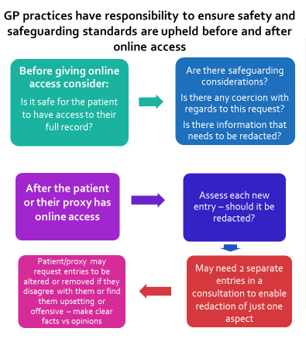

Practical Elements: SystmOne

Three viewing options for patients
- Summary Information
- Detailed Coded Record Access
- Full Clinical Record Access

Once ‘set’ these options will allow access to stated information as it is added to the record unless information is actively redacted or ‘hidden’ from online viewing.

Settings for Redaction or Restricting Access
SystmOne allows professional to mark information as ‘safeguarding relevant’, ‘private’ or ‘do not show in online record’. It is important to note only items marked as ‘do not show in online record’ are not visible to a patient online.
SystmOne setting | Visibility (Professionals) | Visible to a patent online?
Default setting | Information visible to all users who have access to the patient’s record | Yes
Safeguarding Relevant | Only visible to users with ‘safeguarding viewing rights’ | Yes
Private | Only visible to the organisation that entered the data | Yes
Do not show in online record | Information visible to all users who have access to the patient’s record | No  (Patient will not be able to see that information has been redacted)

Hiding consultations from the online record (Redaction)
It is possible to select multiple consultations as hidden from online services in one go.
Go to the Tab Journal or New Journal and select all the consultations you wish to exclude from the online view.
Go to the Online visibility icon and select ‘Do not show in online record’
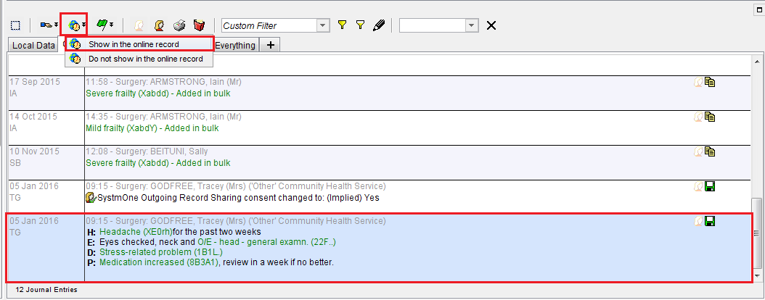
When this option is selected, you will be prompted to enter notes as to why you wish to hide this information from the online record.
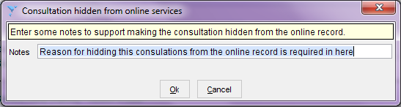
Caution: Hiding information from online visibility WILL NOT redact records when printed

Making a Consultation or Information ‘Private’
This information is not part of the shared record (not seen by other organisations who have access to the record) but is visible to the patient
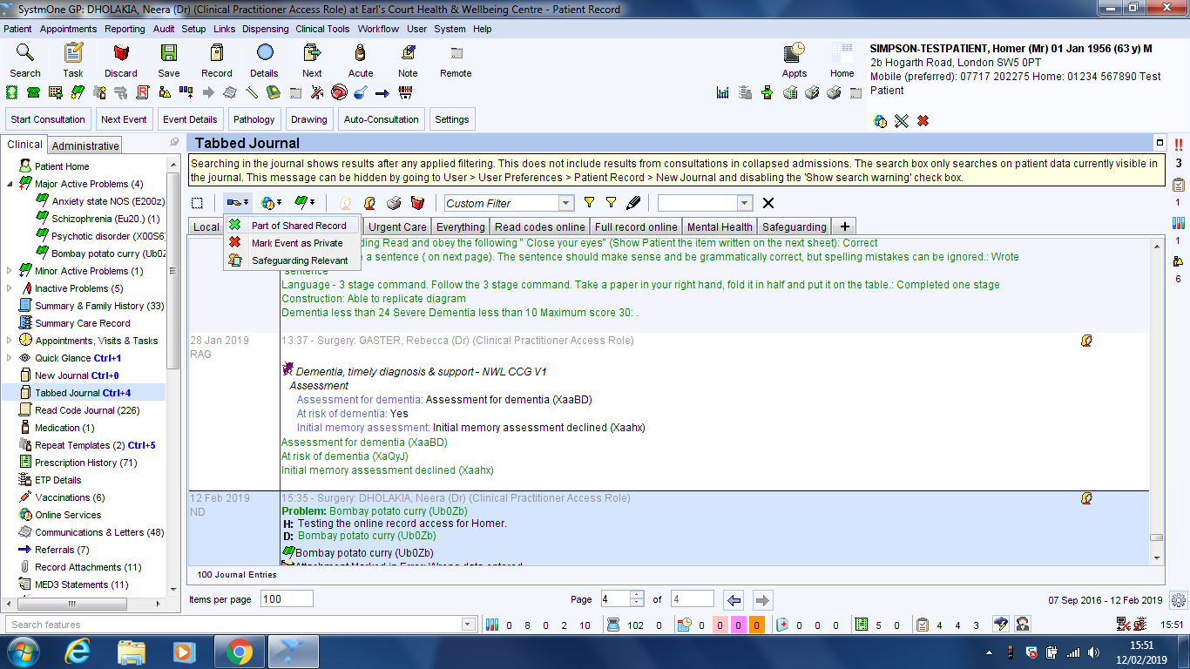

What can the patient see on their online record?
To review what is visible to the patient online, there are 2 methods.
- Go to ‘New Journal’ if this is configured for you and use the drop-down box with Custom Filter to select the view you require
- Set up tabs for Read Code or Full Record Access visibility

Example of setting up tabs:
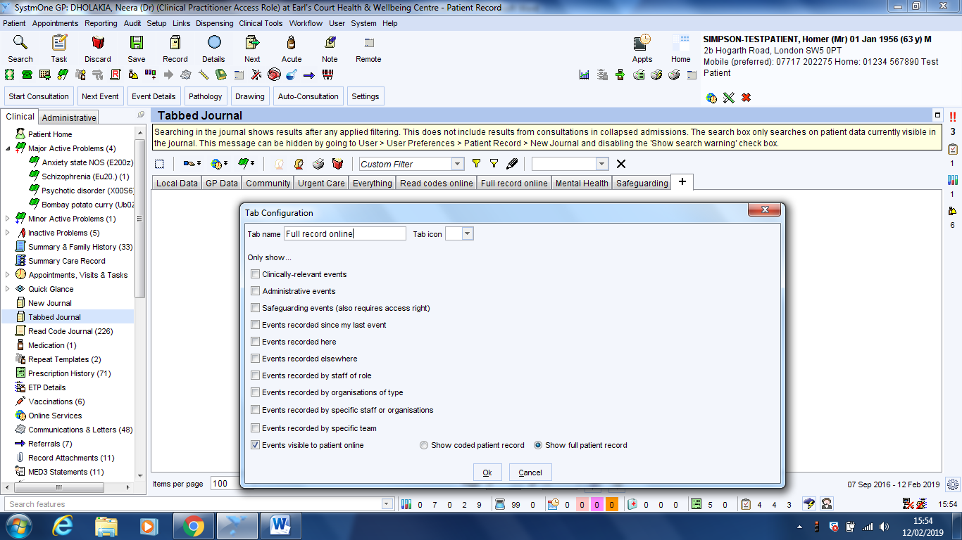

Practical Elements: EMIS

Configuration options for global settings
Guides available at www.emisnow.com within ‘Online Services’.
Practices using EMIS can override individual patient settings, disabling features in EMAS Manager
Click , point to System Tools, and then click EMAS Manager.
Practices can enable/disable transactional services such as appointments and repeat prescriptions.
Practices using EMIS can manage online access settings for patients. Once ‘set’ these options will allow access to stated information as it is added to the record unless information is actively redacted or ‘hidden’ from online viewing.
Option | What the patient will see
No care record access  Disable all care record access | No Care Record data.
Core summary care record  Use summary care record settings | Medication and allergies only.
Detailed coded record  Use detailed coded record settings | Allergies, medications, laboratory test results, immunisations, problems, and read coded data within consultations.  Note: Free text can be controlled separately for:  Lab results  Documents  Problems  Consultations  Referrals/letters/ attachments will become mandatory from April 2020.

Prospective detailed coded record
You can allow certain information, e.g. documents, consultations or free text, to be displayed to the patient, but only going forward from a certain date, e.g. from 1 April 2020. See example screen shot below

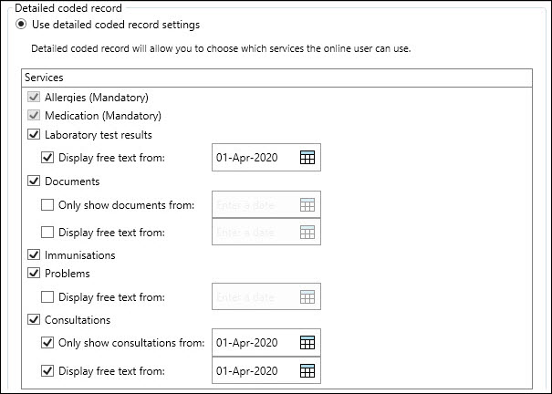

Patient précis icons
The following icons are visible in the patient demographic ribbon to highlight status

Online Services user status
Icon | Colour | Status
 | Black | Not registered
 | Amber | Active
 |  | Inactive
 | Green | Live
Proxy status
 | Black | No linked proxy users
 | Green | Has 1 (or more) linked proxy users

Child Proxy access - Age maturity notifications
A parent or carer can be granted online services on a proxy access basis ‘child proxy access’, such an account will be restricted with access to book one appointment only when the patient reaches the age of 11 years. Emails will be sent to the proxy access user 3 months before and on the patient’s 11th birthday.
For patients under 16 years wishing to register as online users for their own account there is a requirement to record their competency prior to registration as an online user.

Settings for Redaction or Restricting Access
EMIS allows professionals to restrict elements of access within EMAS manager on a case by case basis e.g. give patient access to appointment booking and medications only.
The ‘Online Visibility’ tool within EMIS allows the professional to remove consultation, code, item, or document to be hidden from online visibility, within the open consultation and care history tab. The Problem page view will remain unchanged.

Hiding consultations from the online record (Redaction)
Within the open consultation click on the Online visibility icon and select ‘Do not display on the patient’s online care record’
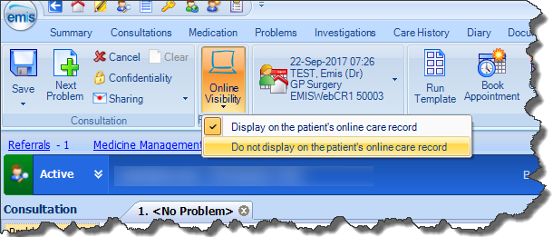
Once saved the crossed icon appears along the right-hand side of the whole consultation.
Caution: Hiding information from online visibility WILL NOT redact records when printed

Hiding parts of care record from the online record
Right- click on the code/item/document in care history, choose Online visibility and then ‘Do no display on the patient’s online care record’
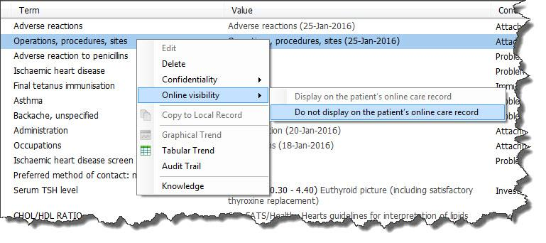
Once saved the crossed icon appears along the right-hand side of the entry. This WILL NOT redact any identical entries codes further within care history. It must be done on an entry by entry basis.

