|  |  |
| --- | --- |
| **Consultants:**  **Dr. Bidisha Lahoti (Clinical Director)**  **Dr Anupama Agrawal (Named Dr LAC)**  **Dr. Nikki Baatjes** Dr. Beatrice CooperDr. Kavitha Gunasuntharam **Dr. Ros Healy**  **Dr. Stacy John-Legere (Designated Dr LAC)**  **Dr. Eleni Stathopulu**  **Dr. Jessica Turnbull**  **Dr. Anne Wright**  **Nurses:**  **Angela Brown (Named Nurse LAC)**  **Helen Corry (Specialist Nurse LAC)**  **Naomi Sandford (Nurse for LAC)**  (GP Practice) | Community Health Services  Looked After Children Health Team  ***Sunshine House***  ***Southwark Children and Young People’s***  ***Development Centre***  ***27 Peckham Road***  ***LONDON***  ***SE5 8UH***  ***Tel: 0203 049 8037*** |
|  |  |

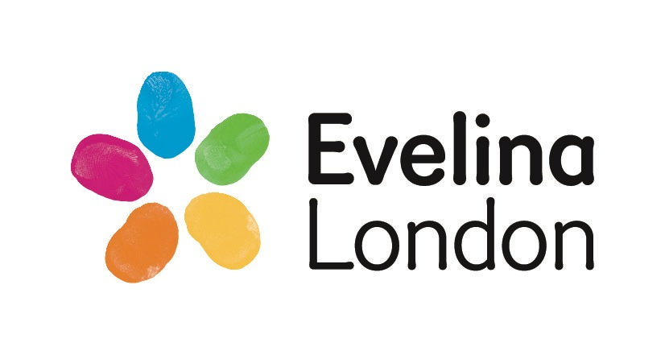Date

Dear

**RE: Surname: First name:**

**NHS no:**

**DOB:**

**Address:**

**Social Worker: Tel:**

CARE LEAVER

We wish to notify you that the above Young Person is a CARE LEAVERfrom Southwark Local Authority. Please make sure that there is an alert on your system that identifies this young person who was previously a Looked After Child. It is recommended that the following Snomed code is used to identify them:

**Care Leaver - (Snomed 770347003).**

**Please make sure that this is coded on the Significant Active problem list** .

(Name)__________________________ will be aged 18 years old on the (Date)______________________

You will be sent a copy of the statutory health assessment and health recommendations from the Looked After Children’s health Team.

We know from research evidence that the mental and physical health outcomes for Looked After Children when they progress into adulthood are poor, as they will have experienced at least one (and often several) Adverse Childhood Experiences (ACEs). Please bear this in mind and consider offering this care leaver an opportunity to discuss their physical, sexual, and mental health, and offer lifestyle advice.

Please discuss with your Safeguarding Lead if you have any concerns re: risks and vulnerabilities for the Young Person.

If you have any queries. Please contact the Southwark Looked After Children’s Health Team by telephoning 0203 049 8037.

Thank you.

Yours sincerely,

Dolly Agrawal

Named Dr for Looked After Children, Southwark

Angela Brown

Named Nurse for Looked After Children, Southwark