Child Protection Conference Report
Following Signs of Safety Principles

Notes for use: Please complete this form electronically; the text boxes will expand to fit your text.
The completed form contains personal data to be protected and processed in line with the Data Protection Act 1998.
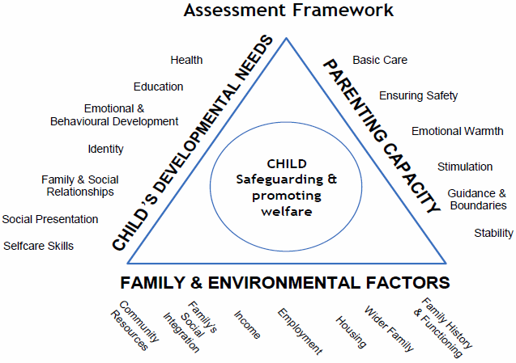 | Please advise the chair in advance if there is any information in this report that should not be shared with other agencies or the parents who have been invited to the conference

Submitting Agency
Date of Report
Professional’s Name
Designation
Address
Contact details
Secure e-mail address

Family Details-Child
Forename (s)
Surname (s)
Home address
DOB/EDD

Family Information: siblings (subject and not subject), Parents, Carers, Significant Family or Household Members
Forename (s) | Surname (s) | DOB | Relationship to Child

Overview of Agency Involvement with child/family
Education - Please include which school/nursery the child/ren attend/registered with and information about educational needs including current arrangements to meet educational needs.
Health - Please include outcome of any relevant health/development assessments and significant medical history.
Other Agencies - Please include the goals or desired outcomes of the work and timescales of involvement.

When was/were the child/ren last seen?
Education - Please include attendance, punctuality and attainment.
Health - Level of engagement, attendance/non-attendance/concordance with treatments.
Other Agencies – programme of the work, and quality and frequency of contact with the child/ren.
Any outstanding actions?
Education - any outstanding educational provision, any transition arrangements.
Health - immunisations/health reviews/ hospital appointments pending.
Other Agencies - any assessments/programmes of work not completed, timescale for completion.

What is going well/ what are the strengths for this child/family?
Please identify any factors that potentially act to protect the child(ren) within and outside of the family, including the significance of reducing the probability of future harm through use of the assessment framework i.e. parenting capacity, child’s development, family and environment
What are you worried about/Risks?
Include factors which you consider to pose risk of significant harm or increase the risk of harm to the child(ren) through the use of the assessment framework i.e. parenting capacity, child’s development, family and environment. Please state name of child if specific concern relates to a particular child.
Past Harm to Children
Include any previous history of concerns within the family, behaviours or actions of concern, details of incidences, severity and impact.
Future Danger for Children
Your professional opinion on the current risks and what you believe to be the likely outcome for the child(ren) if their current situation continues?
What needs to happen next?
Future safety/protection/safety goals- What changes would you need to see in the family to assure you that the risk of harm to the children is sufficiently reduced?
What can your agency contribute to the plan to help keep the child safe?
Complicating factors
Any factors which make the situation more difficult to resolve

Signature of person completing report

Has this report been shared with the parent/carer? | Y/N | Has this report been shared with the child/young person? | Y/N

What are the views of the parents/carers and /or the child(ren) young person on this report?
(If has been possible to ascertain?)

Any Additional relevant information:

Please return the report to:
Quality Assurance Unit, Sumner House Sumner Road, SE15 5QS
qaucpadmin@southwark.gov.uk (password protected)
020 7525 3308 (tel)

It is the responsibility of all agencies who have participated in the enquiry or who have relevant information to make this available to the conference in the form of a legible and signed report.
The report must be received at Quality Assurance Unit at least 1 working day before an initial conference and 5 working days before a review conference.

